Teacher Table

|  |  |  |  |  |  |
| --- | --- | --- | --- | --- | --- |
| No | Name | Dept | Start Date | Age | Gender |
| 1 | Naga | SQL | 2022-01-01 | 30 | F |
| 2 | Renu | Python | 2021-12-05 | 33 | F |
| 3 | Minnu | PSLB | 2021-07-03 | 32 | F |
| 4 | Deepthi | Data Analytics | 2022-02-01 | 32 | F |

Student Table

|  |  |  |  |
| --- | --- | --- | --- |
| SNo | SName | Tname | Status |
| 1 | Amizhthan | Minnu | Not Done |
| 1 | Amizhthan | Naga | Done |
| 2 | Catherine | Renu | Done |
| 2 | Catherine | Naga | Done |
| 3 | Tej | Minnu | Not Done |
| 3 | Tej | Naga | Done |
| 4 | Vijay | Renu | Done |
| 4 | Vijay | Naga | Done |
| 5 | Narayan | Renu | Done |
| 5 | Narayan | Naga | Done |
| 6 | Mugesh | Renu | Done |
| 6 | Mugesh | Naga | Not Done |
| 7 | Rakesh | Renu | Done |
| 7 | Rakesh | Naga | Done |
| 8 | Prabhu | Minnu | Not Done |
| 4 | Vijay | Deepthi | Not Done |
| 9 | Pradeep | Naga | Not Done |
| 7 | Rakesh | Deepthi | Not Done |

1. Create two tables Student, Teacher. (No need of Constrains). (Read next question also before creating the table)



1. Keep Status from Student table as ENUM constraint allowing only values (‘Done’,’Not Done’).



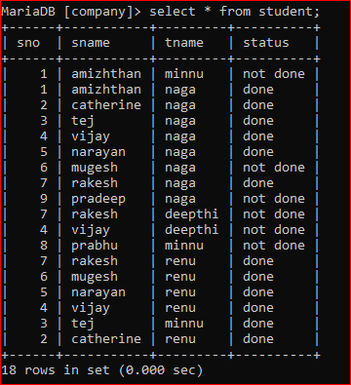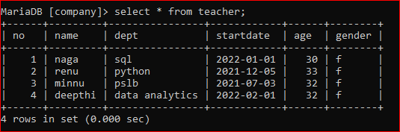

1. List of Student who has completed sql and python.

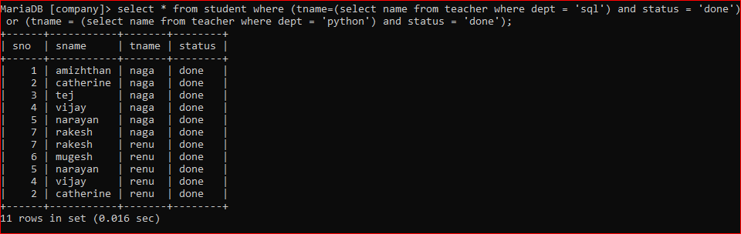

1. Count of students allocated for each teacher.

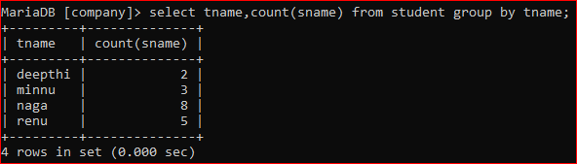

1. Number of students who has more than 5 letters in their names.

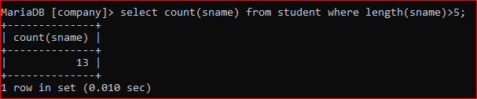

1. Display Student details who is allocated with SQL, Python and Data Analytics.

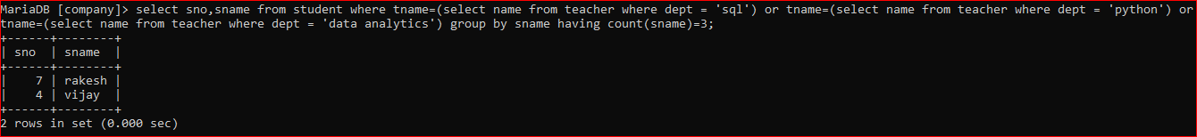

1. Join both the tables and display all the entries of Student table.

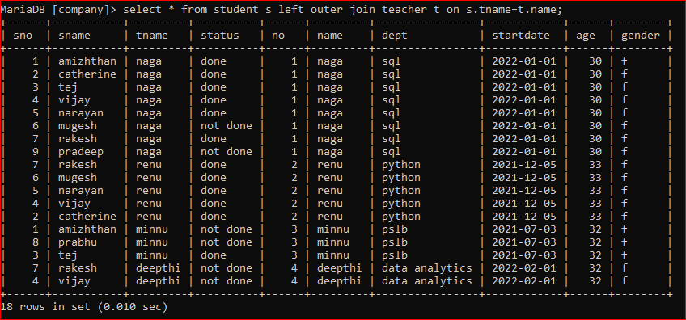

1. List of Students who has completed SQL and not completed PSLB.

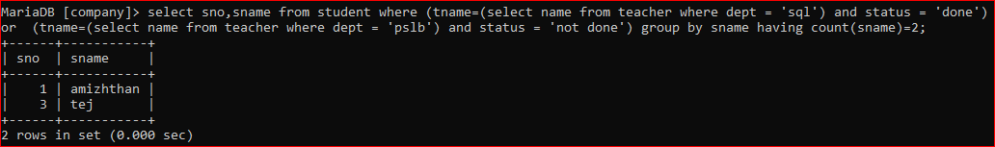

1. Number of students allotted for each teacher.
2. Find the number of days from the Start date the batch is allocated for all the departments.

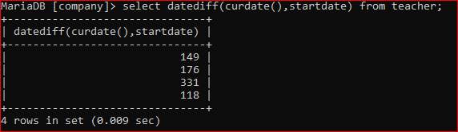

1. Create a virtual table containing name of the student, name of the teacher, department who has not completed.

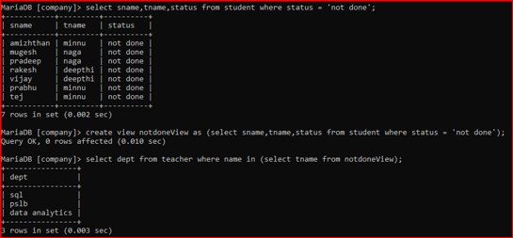

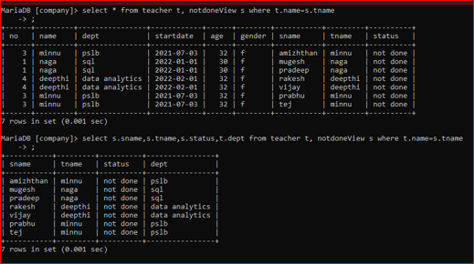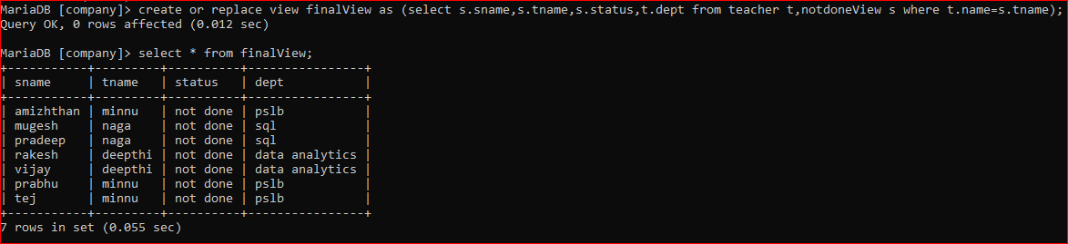

1. Names of the students who has been allotted with maximum number of departments and minimum number of departments.

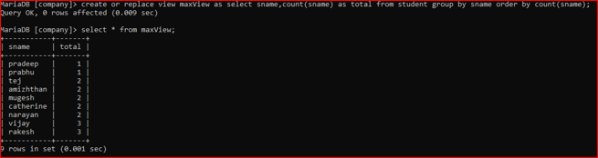

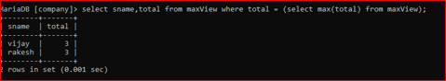

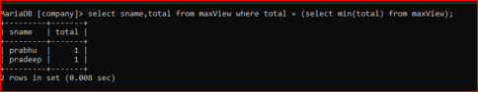

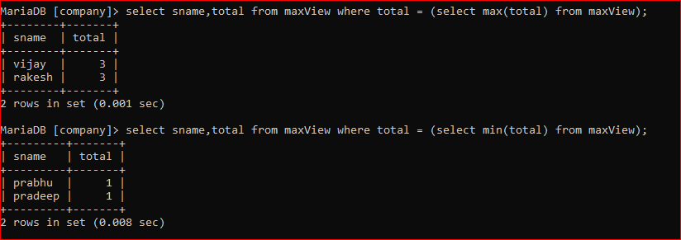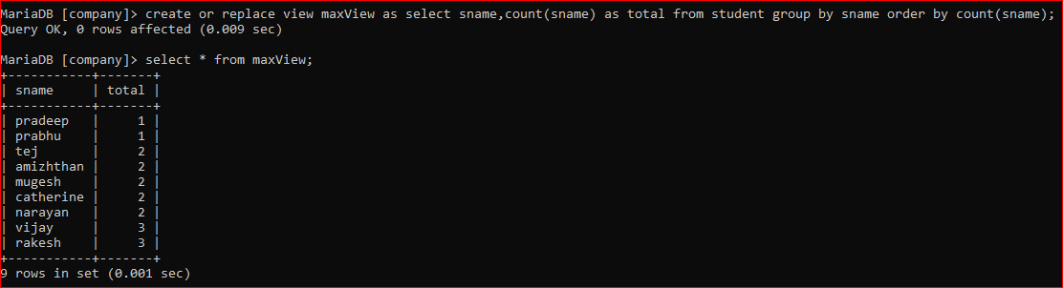

1. Display the details of the second eldest teacher. (First eldest age is 33, Second eldest is 32)

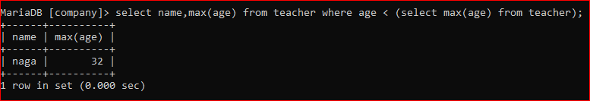

1. Display the names of the students whose names starts with letters between M and T.

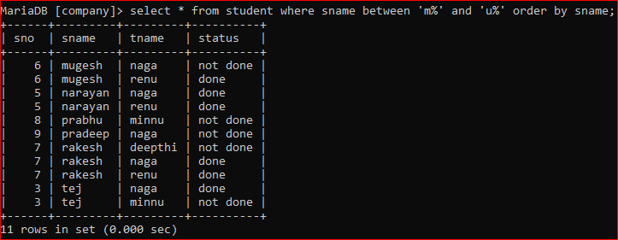

1. Drop the virtual table.

